Case 5-Asia-China-Hongshan-Liaoning-Pig Dragon-Jade-紅山 - 遼寧 - 豬龍-玉-2.4 in

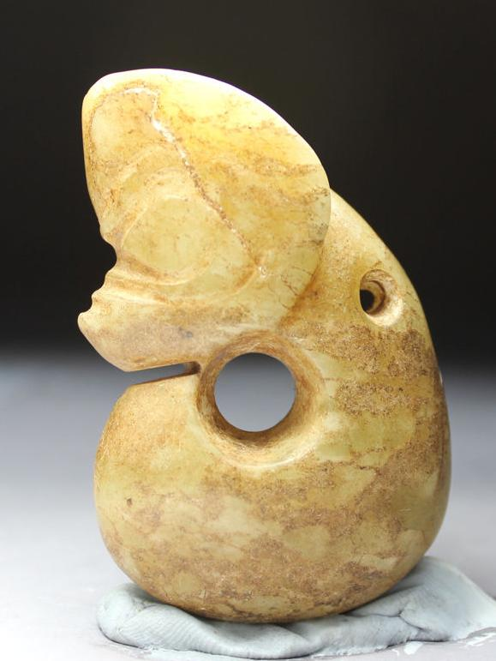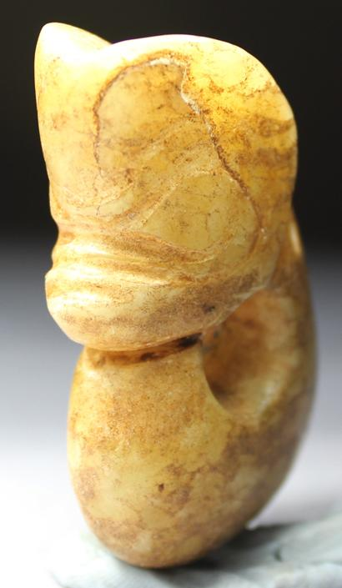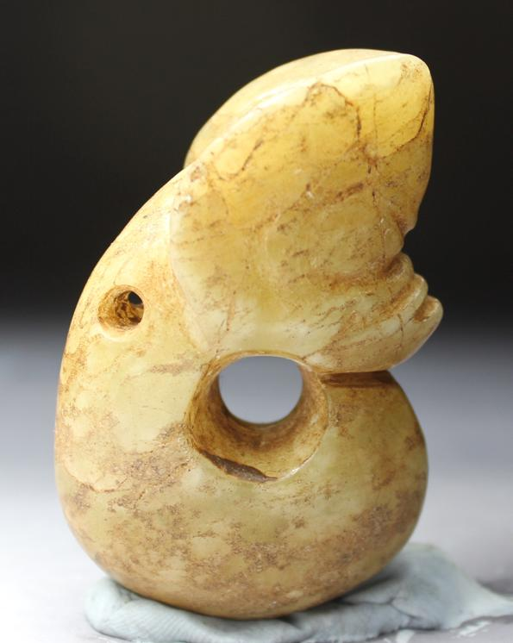

Figs. 1-3. Hongshan-Liaoning-Pig Dragon-Jade-紅山 - 遼寧 - 豬龍-玉-8.5 in

**Case no.: 5**

**Accession Number: A000**

Formal Label: Hongshan-Liaoning-Pig Dragon-Jade-紅山 - 遼寧 - 豬龍-玉-8.5 in

**Display Description:**

This Hongshan Pig-dragon jade carving from Liaoning (紅山-玉--豬頭龍--建平--遼寧)is a zoomorphic, figurine with a pig-like snout and pointed ears on an elongated, "suggestively fetal” or serpentine, limbless body, coiled around a central axis (see Childs-Johnson 1991). Early Hongshan pig-dragon jade carvings (ca 5000 BCE) have stout, pig-like bodies, while later Hongshan examples (ca 3000 BCE) have slender, serpentine bodies. Since pig-dragon jade carvings have been excavated as Hongshan grave goods (Howard 2006), and since pig bones have accounted for 60 percent of animal bones recovered from Hongshan sites, it is inferred that pigs were important not only for the Hongshan economy but also for their symbolic significance. The melding of a fetal-serpentine shape with that of a pig may have been intended to couple an ancient dragon-serpentine shape with that of an economic icon producing a powerful Hongshan foundational image.

The Shang (ca 2000 BCE) written sign for a dragon  , incorporates motifs. For instance, the top of the emperor’s tall crown is capped with a dragon’s horn**立** resembles the and also symbolizes an, **月** portrays a large open mouth with two big front teeth inside, and  **>** depicts a head , a 4-legged body  and a tail .This Shang glyph incorporates a 4-legged body which is legless and serpentine in Hongshan pig-dragon images.

**LC Classification:**

**Date or Time Horizon:**

**Geographical Area:** Liaoning Province

**Map:**

**GPS coordinates:**

**Cultural Affiliation:** Hongshan

**Medium:** jade

**Dimensions:** **H 2.4 in, W1.5, D 0.7 in**

**Weight:**

**Condition: original**

**Provenance:** Jianping

**Discussion:**

In contrast to the Graeco-Roman and Judaeo-Christian-Muslim notions of the soul as the essence of a human being, the Hongshan people of ancient China regarded the soul as the source of their material sustenance that is composed of beings, both animal and human, that personify the bodily essence of their native selves.

To the Hongshan people the pre-eminent animal was the wild boar that was originally hunted in the Mulanshan -- mountains of great, natural wilderness. Images of Mulanshan were conceived by Hongshan sculptors of jade, the stone of immortality, as rounded summits with burrows of the wild boar as circular hollows within these mountains. Images of the wild boar were sculpted on the ends of these mountains -- with their hollows -- making the identity of the sculpture explicit. Thus, this entire sculpture – boar, mountain and burrow -- became the emblem of the Hongshan essence of life.

To further exemplify the source of this essence of life, images of the wild boar as a curled-up fetus about to emerge from the womb, were also sculpted from jade. These sculptures ranged in size from personal amulets to large figures hung in ritual sanctuaries. Their presence was intended to recall the time when these wild boars were first captured and then later domesticated for animal husbandry, thereby marking the moment at which the Hongshan culture emerged from its hunting-gathering existence into a Neolithic, sedentary existence capable of creating such provocative reminiscences of the ancient past.

The Hongshan conception of culture and community required that all participate in this memory of the ancient ways of hunters who could assume the personae of the hunted so that the life of their communities could be sustained in an otherwise alien world. To understand the Hongshan self, one needs to be open to assume this shamanic posture of ecstasy, of being able to stand outside of one’s self and to assume the identities of nature -- both wild animals and humans -- without alterity or division. Furthermore, this was a call to assume the blending of souls, the breaking down of one’s ego and one’s acceptance of the Other. Only this opens a window into one’s own identity and alterity, and with it one’s extension of the self into nature, both of animals and humans, where alien types of being and memory can become palpable.

2) Hongshan-Liaoning-Porcine Torus-Pig Dragon-Abstract-Jade-4700-2920 BCE

 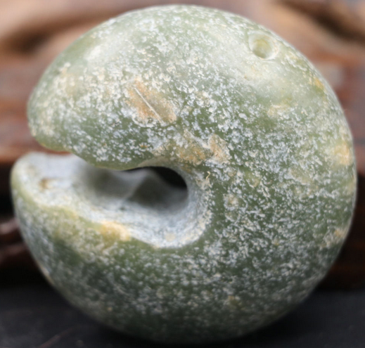 

This example of a porcine torus of revolution (note hole for suspension) has an opening that suggestively shows a boar’s jagged teeth. H 5.4 cm, W 5.4 cm, T 2.4 cm. Atlantika Collection.

3) Hongshan-jade-three-hole, double-boar device-with base tenon-4700-2920 BCE

 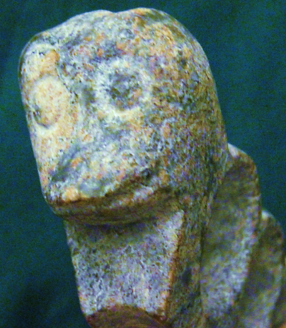

This porcine device has three tori with a suggestive domesticated boar’s head at both ends. The tops of the three tori are considered to be three summits of a mountain range in Liaoning Province that appear like three rounded humps in outline, perhaps home to *Sus scrofa* or wild boar. Atlantika Collection

4) Hongshan-Jade-Porcine Torus-Open-Boar-4700-2920 BCE

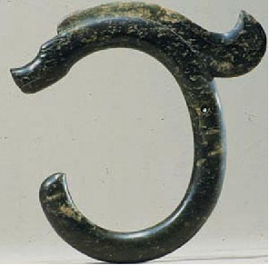

This elliptical porcine torus is open at the front with its “tail” and its blunt snout (suggestively of the non-domesticated *Sus scrofa* or wild boar) are opposed. To add motion to this more serpentine shape, a flowing mane has been added. Atlantika Collection.

**5) Sheep sculptures as Hongshan Culture Expands Trade and Exchange into Mongolia**

Sheep sculptures were added by artisans to their porcine repertoire as Hongshan trade and exchange with Mongolian sheep herders developed. This suggests increasing cultural complexity and stability, although the degree of complexity and Hongshan connections to other emergent Neolithic cultures in Mongolia and Central Asia are still under debate (Guo 1985).



 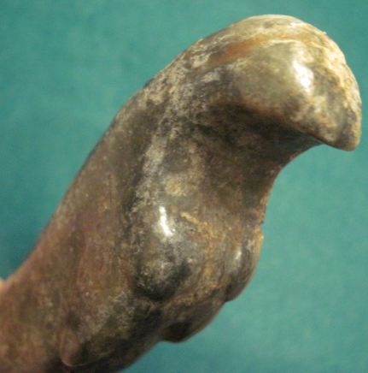

Rare mid-late Hongshan sheep sculpture, ca 2500 BCE, Atlantika Collection

**6) Climatic fluctuations 4000-2200 BCE**: **development and demise of the Hongshan culture.**

Between 3678-3400 cal. BCE the climate was colder and drier than today. Then, from 3400- 2800 cal. BCE the climate was much warmer and wetter. Between 2800-2300 cal. BCE the climate was persistently cold, with an exceptionally cold event occurring between 2600-2300 cal. BCE. This cold event was recorded at several other localities in Northern China and in the Northern Hemisphere. It played an important role in the emigration of Inner Mongolian people from the Hunshandake Sandy Lands of Inner Mongolia (Yang et al. 2015) to immigrate to the Yangtze River delta and in turn they forced the Hongshan people to emigrate to Taiwan by 2200 BCE, a date that corresponds to the demise of the Hongshan culture which has been an enigma until now (Jin and Liu. 2002).



Map showing location of Hunshandake Sandy Lands outlined in black.

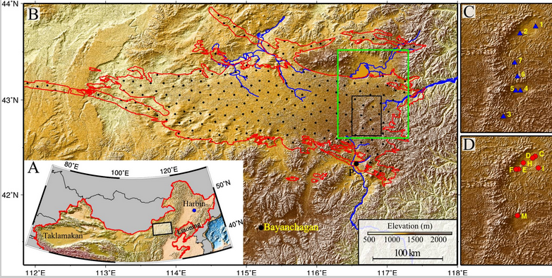

Geographical location of the Hunshandake Sandy Lands (A) and its area (encompassed by red line in B).

The black rectangle in B marks the location of the enlarged maps C and D on the Right, and the green rectangle shows the location of [Fig. 2](https://www.ncbi.nlm.nih.gov/pmc/articles/PMC4311860/figure/fig02/). Map C shows the localities of water samples, and map D shows the localities of stratigraphy The sand–paleosol section P ([Fig. 3](https://www.ncbi.nlm.nih.gov/pmc/articles/PMC4311860/figure/fig03/)) is on the southern margin, and the site Bayanchagan marks the coring site to sample the paleosols (Jiang et al. 2006). Rivers with headwaters in the Hunshandake likely formed by groundwater sapping are marked in blue. Drainages to the southwest and west are currently undergoing groundwater sapping, with substantial spring-driven flow found at the current river base level. From <https://www.ncbi.nlm.nih.gov/pmc/articles/PMC4311860/figure/fig01/>

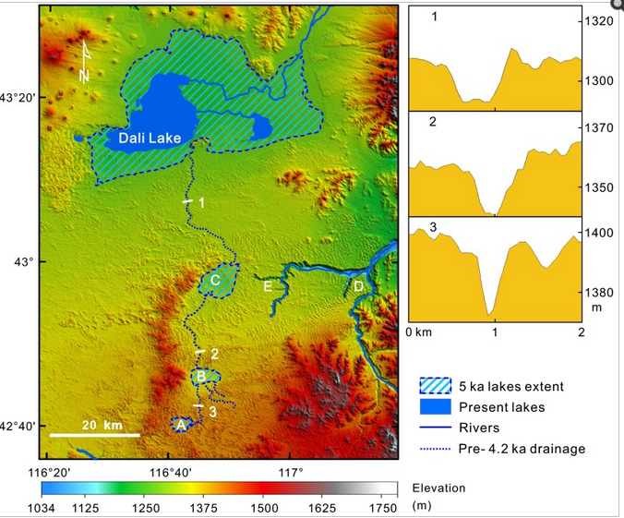

Map of the desiccation of Holocene lakes and channels in the Hunshandake Sandy Lands at selected epochs (Yang *et al*. 2015). Upper, middle, and lower lakes are indicated by points A, B, and C, respectively. Xilamulun River (point D) drains to the east. Groundwater-sapping headcuts at the upper reaches of incised canyons (point E) suggest a mid-Holocene interval of easterly surface flow, followed by groundwater drainage beginning at the ca. 4.2 ka event. Northern and central channels at point E are currently abandoned, and groundwater sapping has migrated to the southerly of the three channels shown. (Right) Cross-sections of the predrainage shift, northerly drainage into Dali Lake (Localities shown on the Left), showing the increase in widths of channels downstream (Vertical exaggeration ∼30:1).

**References**

Anderson, E. N., JR. I988. *The food of China.* New Haven: Yale University Press.

Blench, Roger. 2004. “Human migrations in continental East Asia and Taiwan: genetic, linguistic and archaeological evidence. Université de Genève” [DRAFT CIRCULATED FOR COMMENT]

Chang K. C. I977. *Food in Chinese culture*. New Haven: Yale University Press.

1986. 4th edition. *The archaeology of ancient China*. New Haven: Yale University Press.

1989. "Ancient China and its anthropological significance." In *Archaeological thought in America*. Edited by C. C. Lamberg-Karlovsky, pp. I 55-66. Cambridge: Cambridge University Press.

Childs-Johnson, Elizabeth (1991). "Jades of the Hongshan culture: the dragon and fertility cult worship," Arts asiatiques, **46**: 82–95.

Cohen, M. N., and G. J. Armelagos.1. *Paleopathology at the origins of agriculture*. Orlando: Academic Press.

Freid, M. H. I967. The evolution of political society. New York: Random House.

Freidman, J., and M. J. Rowlands. I978. "Notes towards an epigenetic model of 'civilization,"' in *The evolution of social system*. Edited by J. Friedman and M. Rowlands, pp. 20I-76. London: Duckworth.

Gao, G. I978. “Dawenkou culture its nature and chronology” (大汶口文化的性质和年代), *Kuangmingribao*, April 27.

Guo, Da-Shun 1995. Hongshan and related cultures. In: *The archaeology of Northeast China: beyond the Great Wall.* Nelson, Sarah M. ed. 21-64. London and New York: Routledge.

Guo D. *Hongshan Culture(红山文化*). Artifacts Press; Beijing: 1985.

Jiang W, et al. 2006. Reconstruction of climate and vegetation changes of Lake Bayanchagan (Inner Mongolia): Holocene variability of the East Asian monsoon. Quat Res. 65(3):411–420.

Jin, G. and Liu, D. 2002. Mid-Holocene climate change in North China, and the effect on cultural development. *Chinese Science Bulletin*, *47*(5), pp.408-413.

Jing Y, Flad R. 2002.” Pig domestication in ancient China,”. Antiquity 76: 724–732.

Jing Y, Jianlin H, Blench R. 2008. “Livestock in ancient China: an archaeo-zoological perspective.” In: Sanchez-Mazas A, Blench RM, Ross M, eds. Human Migrations in Continental East Asia and Taiwan. Genetic, Linguistic and Archaeological Evidence. Routledge; Abingdon: New York.

Johnson, A. W., and T. Earle I987. *The evolution of human society: From foraging group to agrarian state*. Stanford: Stanford University Press.

Keibel F. 1897. *Normentafeln zur Entwicklungsgeschichte der Wirbelthiere*, (*Sus scrofa domesticus*). Bd. 1. Jena: Fisher, v. 1, pl. 2, no. 16.

Kaogu. I979. “Summary of the debate on the nature of Dawenkou society and related questions (关于大汶口社会性质辩论及相关问题的总结),” *Kaogu*, no. I, pp. 33-36.

Larson G, Dobney K, Albarella U, Fang M, Matisoo-Smith E, Robins J et al. 2005. “Worldwide phylogeography of wild boar reveals multiple centers of pig domestication,” *Science* 307: 1618–1621.

Larson G, Liu R, Zhao X, Yuan J, Fuller D, Barton L et al. 2010. « Patterns of East Asian pig domestication, migration, and turnover revealed by modern and ancient DNA,” *Proc Natl Acad Sci USA* 107: 7686–7691.

Lee, Y. I96I. “Mortuary practices of Wa people and the research on burial practices in prehistoric China (佤族的太平间做法，在中国史前丧葬习俗研究),” *Kaogu*, no. 7, pp. 37I-74.

Rappaport, R. 1967. *Pigs for the ancestors*. New Haven: Yale University Press.

Sahlins, M. A. I970. "Poor man, rich man, big-man, chief: Political types in Melanesia and Polynesia," in *Cultures of the Pacific*. Edited by T. G. Harding and B. J. Wallace, pp. 203-I5. New York: Free Press. . I972. Stone Age economics. New York: Aldine.

Sanders, W. T., and D. Webster. I978. "Unilinealism, multilinealism, and the evolution of complex societies," in *Social archaeology: Beyond subsistence and dating*. Edited by C. Redman, M. Berman, E. Curtis, W. Langhorne, N. Veraggi, and J. Wanser, pp. 249-302. New York: Academic Press.

Saxe, A. I970. *Social dimensions of mortuary practices*. Ann Arbor: University Microfilms.

Service. 1962. *Primitive social organization*. New York: Random House.

I975. *Origins of the state and civilization*. New York: Norton.

Shandong Provincial Museum. *I978.* “Remarks on Dawenkou culture (论大汶口文化),” *Wenwu,* no. 4, pp. 58-66.

Tang, L. I977. Origins of earliest culture in China as seen from the writing on pottery (从陶器文字看中国最早的文化起源). *Kuangmingribao*, July I4.

I978. “A discussion of the nature of the Dawenkou culture and the writing on pottery (论大汶口文化的性质与陶瓷文字),” *Kuangmingribao,* February 23.

Taylor, D. I975. “Some locational aspects of middle-range hierarchical societies.” Ph.D. diss., City University of New York.

Tong C. I974. “The origins of private ownership and social stratification in Chinese archaeology,” *Kaogu,* no. 4, pp. 2I3-2I.

Wang, R. I98I. “The religious significance of interring pig carcasses in the Chinese Neolithic (中国新石器时代中国猪尸屠体的宗教意义),” *Wenwu*, no. 2, pp. 79-85.

Wei, J. I976. “Discussion of origins of hierarchical societies in ancient China: An analysis of archaeological data in prehistoric societies (中国古代等级制社会的起源：史前社会考古资料分析),” *Wenwu*, no. 8, pp. I-5.

Wu, J. 1982. “The chronology of Shandong archaeology and related questions (山东考古年表及相关问题),” *Wenwu*, no. IO, pp. 44-56.

Wright, H. I984. "Pre-state political formations," in *On the evolution of complex societies*. Edited by T. Earle, pp. 47-77. Malibu: Undena.

Yang, X., L.A. Scuderi, X. Wang, L.J. Scuderi, D. Zhang D., H. Li, S. Forman, Q. Xu, R. Wang, W. Huang, S. Yang. 2015. “Groundwater sapping as the cause of irreversible desertification of Hunshandake Sandy Lands, Inner Mongolia, northern China,” [*Proc Natl Acad Sci U S A*.](https://www.ncbi.nlm.nih.gov/pubmed/25561539)  Jan 20;112(3):702-6.